Hispanic heritage month

Southern mixer
Join the Hispanic Bar Association at VERA’S BAR AND GRILL
2310 Marlton Pike (Rt. 70)
Cherry Hill, NJ
Open Bar, Music, Food Stations & Friends
October 13, 2022 — 6:00 p.m.
Admission: Free for HBA-NJ, $40 for Non-members
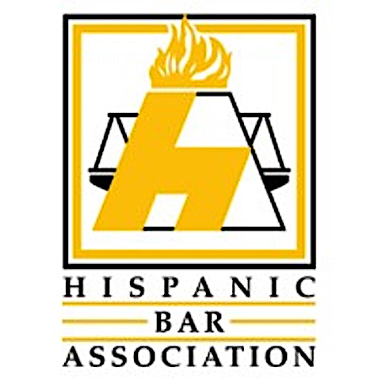
Register at:
For questions or sponsorship opportunities contact:
Jose A. Calves at jcalves@brownconnery.com

